**Big Data Analytics**

**Module 4**

**MapReduce, Hive and Pig**

**Topics Covered**

* Introduction
* MapReduce Map Tasks
* Reduce Tasks and MapReduce Execution
* Composing MapReduce for Calculations and Algorithms
* Hive
* HiveQL
* Pig.

**Introduction**

The data processing layer is the application support layer, while the application layer is the data consumption layer in Big-Data architecture design . When using HDFS, the Big Data processing layer includes the APIs of Programs such as MapReduce and Spark. The application support layer includes HBase which creates column-family data store using other formats such as key-value pairs or JSON file

HBase stores and processes the columnar data after translating into MapReduce tasks to run in HDFS. The support layer also includes Hive which creates SQL-like tables. Hive stores and processes table data after translating it into MapReduce tasks to run in HDFS. Hive creates SQL-like tables in Hive shell. Hive uses HiveQL processes queries, ad hoc (unstructured) queries, aggregation functions and summarizing functions, such as functions to compute maximum, minimum, average of selected or grouped datasets.

HiveQL is a restricted form of SQL. The support layer also includes Pig. Pig is a data-flow language and an execution framework .Pig enables the usage of relational algebra in HDFS. MapReduce is the processing framework and YARN is the resource managing framework Figure 4.1 shows Big Data architecture design layers: (i) data storage, (ii) data processing and data consumption, (iii) support layer APIs for MapReduce, Hive and Pig running on top of the HDFS Data Store, and (v) application tasks. Pig is a dataflow language, which means that it defines a data stream and a series of transformations. Hive and Pig are also part of the ecosystem

.

Big Data storage and application-support APIs can use Hive and Pig for processing data at HDFS. Processing needs mapping and finding the source file for data. File is in the distributed data store. Requirement is to identify the needed data-block in the cluster. Applications and APIs run at the data nodes stored at the blocks. The smallest unit of data that can be stored or retrieved from the disk is a block.

HDFS deals with the data stored in blocks. The Hadoop application is responsible for distributing the data blocks across multiple nodes. The tasks, therefore, first convert into map and reduce tasks. This requirement arises because the mapping of stored values is very important. The number of map tasks in an application is handled by the number of blocks of input files Suppose stored files have key-value pairs. Mapping tells us whether the key is in file or in the value store, in a particular cluster and rack. Reduce task uses those values for further processing such as counting, sorting or aggregating Application sub-task assigned for processing needs only the outputs of reduce tasks. For example, a query needs the required response for a data store.

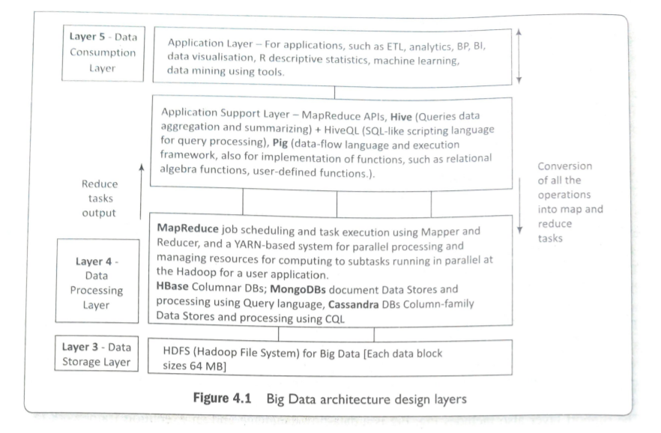

**MapReduce MAP TASKS, REDUCE TASKS AND MapReduce EXECUTION**

Big data processing employs the MapReduce programming model A Job means a MapReduce program. Each job consists of several smaller units, called MapReduce tasks. A software execution framework in MapReduce programming defines the parallel tasks. The tasks give the required result. The Hadoop MapReduce implementation uses Java framework. Figure 4.2 shows MapReduce programming model

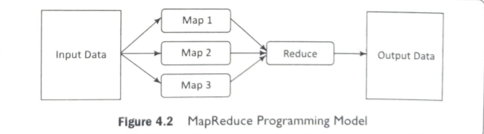

The model defines two important tasks, namely Map and Reduce. Map takes input data set as pieces of data and maps them on various nodes for parallel processing. The reduce task, which takes the output from the maps as an input and combines those data pieces into a smaller set of data. A reduce task always run after the map task (s). Many real-world situations are expressible using this model. Such Model describes the essence of MapReduce programming where the programs written are automatically parallelize and execute on a large cluster.

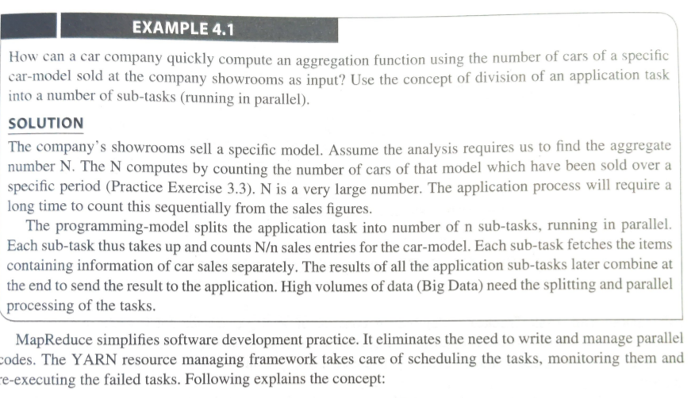

The input data is in the form of an HDFS file. The output of the task also gets stored in the HDFS. The compute nodes and the storage nodes are the same at a cluster, that is, the MapReduce program and the HDFS are running on the same set of nodes. This configuration results in effectively scheduling of the sub-tasks on the nodes where the data is already present. This results in high efficiency due to reduction in network traffic across the cluster.

A user application specifies locations of the input/output data and translates into map and reduces functions. A job does implementations of appropriate interfaces and/or abstract-classes. These, and other job parameters, together comprise the job configuration. The Hadoop job client then submits the job (jar/executable etc.) and configuration to the JobTracker, which then assumes the responsibility of distributing the software configuration to the slaves by scheduling tasks, monitoring them, and provides status and diagnostic information to the job-client. Figure 4.3 shows MapReduce process when a client submits a job, and the succeeding actions by the Job Tracker and Task Tracker.

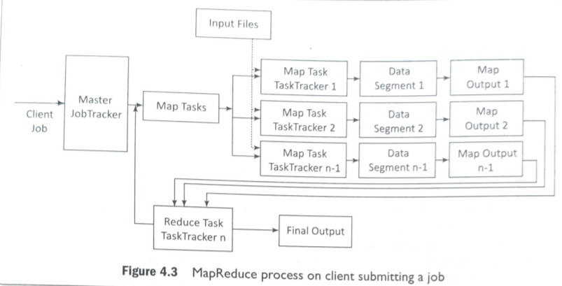

**JobTracker and Task Tracker**

MapReduce consists of a single master JobTracker and one slave TaskTracker per cluster node. The master is responsible for scheduling the component tasks in a job onto the slaves, monitoring them and re-executing the failed tasks. The slaves execute the tasks as directed by the master The data for a MapReduce task is initially at input files.

The input files typically reside in the HDFS. The files may be line-based log files, binary format file, multi-line input records, or something else entirely different. These input files are practically very large, hundreds of terabytes or even more than Most importantly, the MapReduce framework operates entirely on key, value-pairs. The framework views the input to the task as a set of (key, value) pairs and produces a set of (key, value) pairs as the output of the task, possibly of different types .

**Map-Tasks**

Map task means a task that implements a map(), which runs user application codes for each key-value pair (kl, vl). Key kl is a set of keys. Key kl maps to a group of data values .Values vi are a large string which is read from the input file(s). it. The output of map() would be zero (when no values are found) or intermediate key-value pairs (k2, v2).

The value v2 is the information for the transformation operation at the reduce task using aggregation or other reducing functions. Reduce task refers to a task which takes the output v2 from the map as an input and combines those data pieces into a smaller set of data using a combiner. The reduce task is always performed after the map task. The Mapper performs a function on individual values in a dataset irrespective of the data size of the input. That means that the Mapper works on a single data set. Figure 4.4 shows logical view of functioning of map().

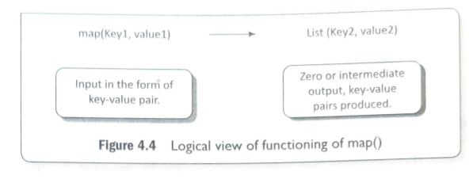

Hadoop Java API includes Mapper class. An abstract function map() is present in the Mapper class. Any specific Mapper implementation should be a subclass of this class and overrides the abstract function, map().

**The Sample Code for Mapper Class**

public class SampleMapper extends Mapper <K1,V1,K2,V2>

{

void map (ki key, vi value, Context context) throws IOException,

InterruptedException

{..}

}

Individual Mappers do not communicate with each other.

**Number of Maps**

The number of maps depends on the size of the input files, i.e., the total number of blocks of the input files. Thus, if the input files are of 1TB in size and the block size is 128 MB, there will be 8192 maps. The number of map task Nmap can be explicitly set by using setNumMapTasks(int). Suggested number is nearly 10-100 maps per node. Nmap can be set even higher

**Key-Value Pair**

Each phase (Map phase and Reduce phase) of MapReduce has key-value pairs as input and output. Data should be first converted into key-value pairs before it is passed to the Mapper, as the Mapper only understands key-value pairs of data . Key-value pairs in Hadoop MapReduce are generated as follows: InputSplit - Defines a logical representation of data and presents a Split data for processing at individual map().

Record Reader - Communicates with the InputSplit and converts the Split into records which are in the form of key-value pairs in a format suitable for reading by the Mapper. RecordReader uses TextInputFormat by default for converting data into key-value pairs. RecordReader communicates with the InputSplit until the file is read. Figure 4.5 shows the steps in MapReduce key-value pairing. Generation of a key-value pair in MapReduce depends on the dataset and the required output. Also, the functions use the key-value pairs at four places: map() input, map() output, reduce() input and reduce() output.

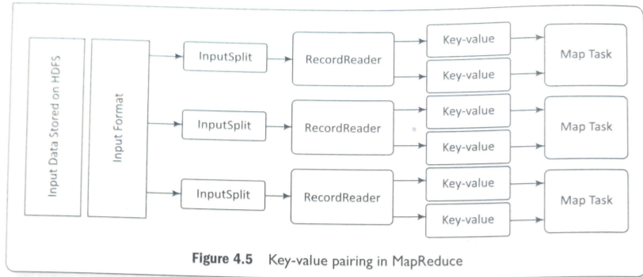

**Grouping by Key**

When a map task completes, Shuffle process aggregates (combines) all the Mapper outputs by grouping the key-values of the Mapper output, and the value v2 append in a list of values. A "Group By” operation on intermediate keys creates v2.

**Shuffle and Sorting Phase**

Here, all pairs with the same group key (k2) collect and group together, creating one group for each key. So, the Shuffle output format will be a List of . Thus, a different subset of the intermediate key space assigns to each reduce node. These subsets of the intermediate keys (known as “partitions”) are inputs to the reduce tasks. Each reduce task is responsible for reducing the values associated with partitions. HDFS sorts the partitions on a single node automatically before they input to the Reducer.

**Partitioning**

The Partitioner does the partitioning. The partitions are the semi-mappers in MapReduce. Partitioner is an optional class. MapReduce driver class can specify the Partitioner. A partition processes the output of map tasks before submitting it to Reducer tasks. Partitioner function executes on each machine that performs a map task. Partitioner is an optimization in MapReduce that allows local partitioning before reduce-task phase. Typically, the same codes implement the Partitioner, Combiner as well as reduce() functions. Functions for Partitioner and sorting functions are at the mapping node. The main function of a Partitioner is to split the map output records with the same key.

**Combiners**

Combiners are semi-reducers in MapReduce. Combiner is an optional class. MapReduce driver class can specify the combiner. The combiner () executes on each machine that performs a map task. Combiners optimize MapReduce task that locally aggregates before the shuffle and sort phase. Typically, the same codes implement both the combiner and the reduce functions, combiner () on map node and reducer() on reducer node.

The main function of a Combiner is to consolidate the map output records with the same key. The output (key-value collection) of the combiner transfers over the network to the Reducer task as input.

This limits the volume of data transfer between map and reduce tasks, and thus reduces the cost of data transfer across the network. Combiners use grouping by key for carrying out this function. The combiner works as follows:

1. It does not have its own interface and it must implement the interface at reduce().
2. It operates on each map output key. It must have the same input and output key-value types as the Reducer class.
3. It can produce summary information from a large dataset because it replaces the original Map output with fewer records or smaller records.

**Reduce Tasks**

Java API at Hadoop includes Reducer class. An abstract function, reduce() is in the Reducer. Any specific Reducer implementation should be subclass of this class and override the abstract reduce(). Reduce task implements reduce() that takes the Mapper output (which shuffles and sorts), which is grouped by key-values (k2, v2) and applies it in parallel to each group. Intermediate pairs are at input of each Reducer in order after sorting using the key. Reduce function iterates over the list of values associated with a key and produces outputs such as aggregations and statistics. The reduce function sends output zero or another set of key-value pairs (k3, v3) to the final the output file. Reduce: {(k2, list (v2) -> list (k3, v3)}

Sample Code for Reducer Class

public class ExampleReducer extends Reducer <K2,V2,K3,V3>

void reduce (k2 key, Iterable values, Context context) throws IOException, InterruptedException

{...}

**Details of MapReduce Processing Steps**

Execution of MapReduce job does not consider how the distributed processing implements. Rather, the execution involves the formatting (transforming) of data at each step. Figure 4.6 shows the execution steps, data flow, splitting, partitioning and sorting on a map node and reducer on reducer node. Example 2.3 described sales data of the five types of chocolates in a large number of ACVMs (Automatic Chocolate Vending Machines).

The example gave answers to the following:

1. how hourly data log for each flavor sales on large number of ACVMs save using HDFS,
2. how the sample of data-collect in a file each for 0-1,1-2, ... 12-13,13-14, 15-16, ... for up to 23-24 specific hour sales,
3. what will be output streams of map tasks which are the input streams to the reduce() tasks, and
4. what will be the Reducer outputs. Let us explore another example, Automotive Components and Predictive Automotive Maintenance Services (ACPAMS). ACPAMS is an application of (Internet) connected cars which renders services to customers for maintenance and servicing of (Internet) connected cars .

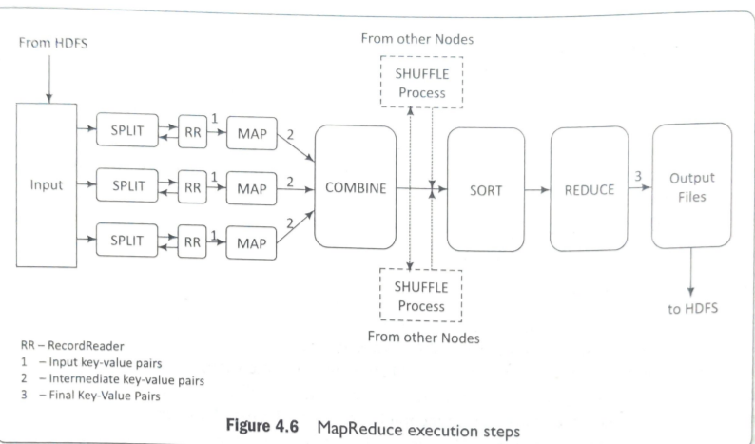

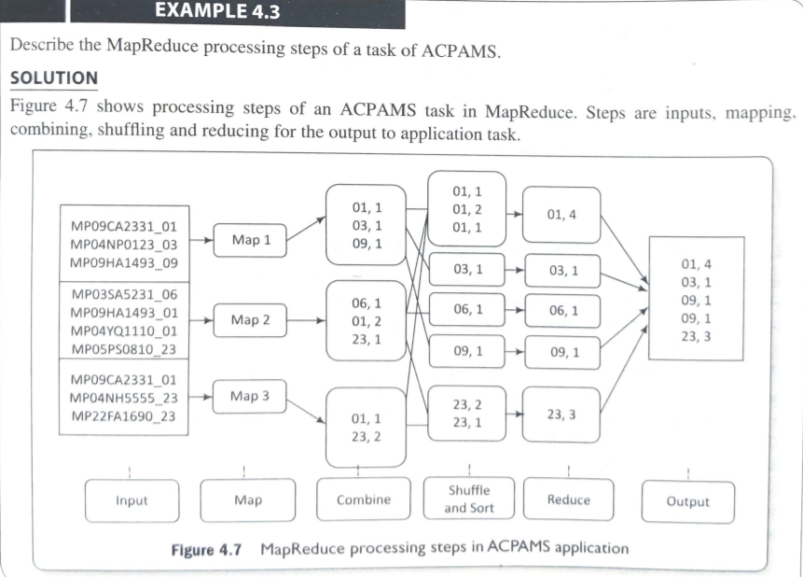

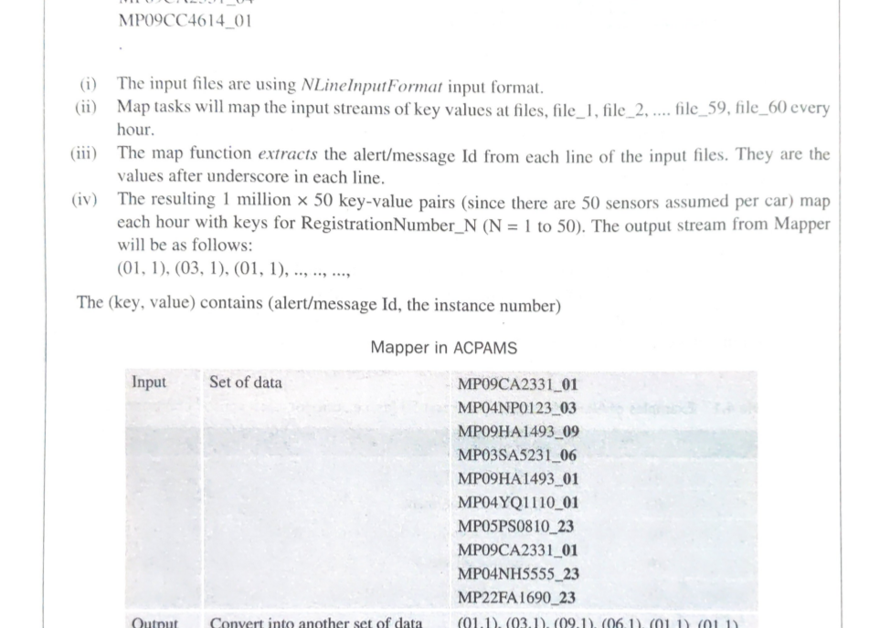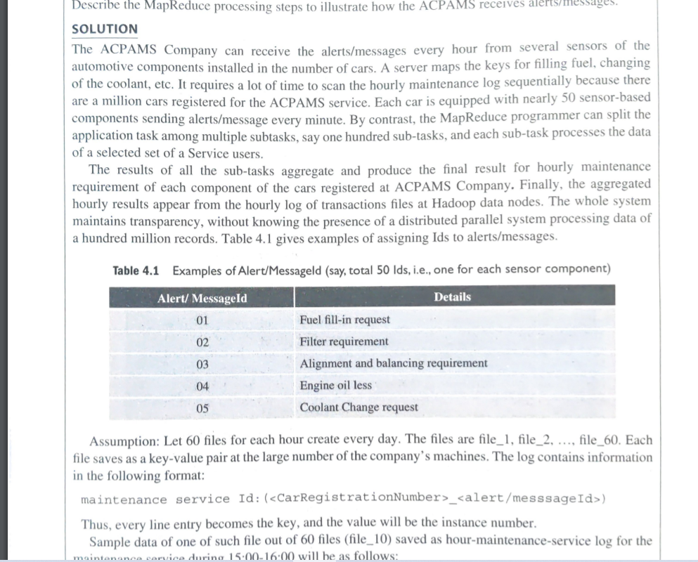

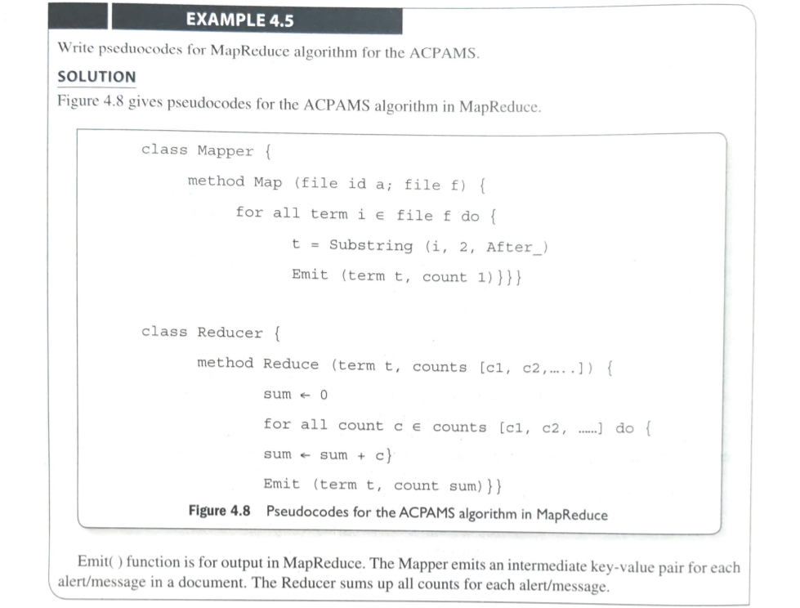

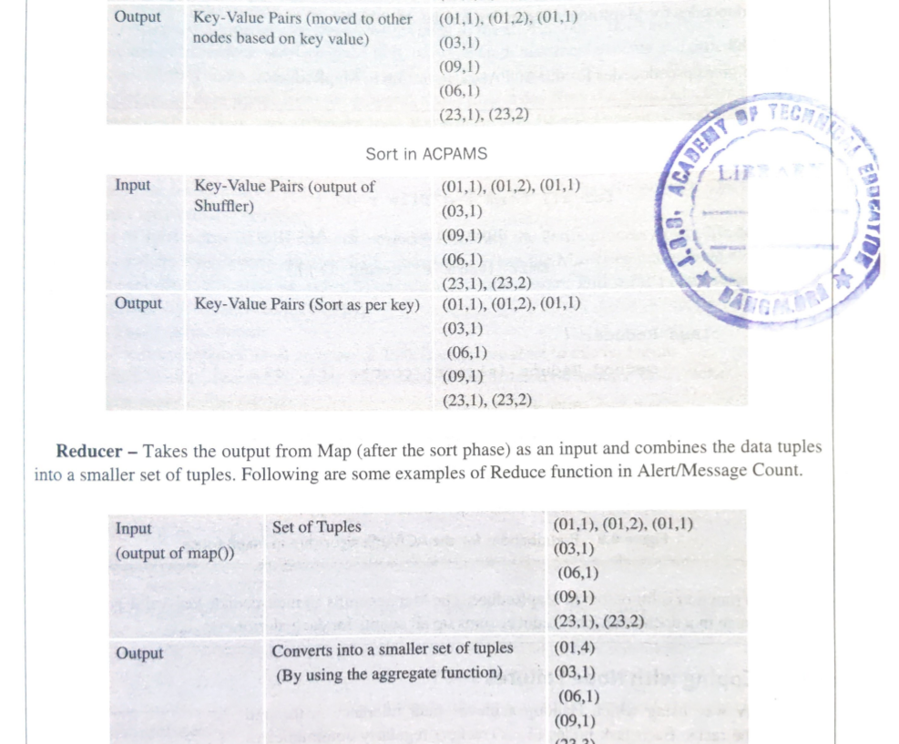

**Coping with Node Failures**

The primary way using which Hadoop achieves fault tolerance is through restarting the tasks. Each task nodes (TaskTracker) regularly communicates with the master node, Job Tracker. If a TaskTracker fails to communicate with the JobTracker for a pre-defined period (by default, it is set to 10 minutes), a task node failure by the JobTracker is assumed. The JobTracker knows which map and reduce tasks were assigned to each TaskTracker. If the job is currently in the mapping phase, then another TaskTracker will be assigned to re-execute all map tasks previously run by the failed TaskTracker. All completed map tasks also need to be assigned for re-execution if they belong to incomplete jobs. This is because the intermediate results residing in the failed TaskTracker file system may not be accessible to the reduce task. If the job is in the reducing phase, then another TaskTracker will re-execute all reduce tasks that were in progress on the failed TaskTracker.

Once reduce tasks are completed, the output writes back to the HDFS. Thus, if a TaskTracker has already completed nine out of ten reduce tasks assigned to it, only the tenth task must execute at a different node. Map tasks are slightly more complicated. A node may have completed ten map tasks but the Reducers may not have copied all their inputs from the output of those map tasks.

If a node fails, then its Mapper outputs are inaccessible. Thus, any complete map tasks must also be re-executed to make their results available to the remaining reducing nodes. Hadoop handles all of this automatically. MapReduce does not use any task identities to communicate between nodes or which reestablishes the communication with other task node. Each task focuses on only its own direct inputs and knows only its own outputs.

The failure and restart processes are clean and reliable. The failure of JobTracker (if only one master node) can bring the entire process down; Master handles other failures, and the MapReduce job eventually completes. When the Master compute-node at which the JobTracker is executing fails, then the entire MapReduce job must restart.

Following points summarize the coping mechanism with distinct Node Failures:

1. Map TaskTracker failure: - Map tasks completed or in-progress at TaskTracker, are reset to idle on failure - Reduce TaskTracker gets a notice when a task is rescheduled on another TaskTracker
2. Reduce TaskTracker failure: - Only in-progress tasks are reset to idle
3. Master Job Tracker failure: - Map-Reduce task aborts and notifies the client (in case of one master node).

**COMPOSING MapReduce FOR CALCULATIONS AND ALGORITHMS**

**Composing Map-Reduce for Calculations**

The calculations for various operations compose are:

**Counting and Summing**

Assume that the number of alerts or messages multiplication generated during a specific maintenance activity of vehicles need counting for a month. Figure showed the pseudocode using emit() in the map() of Mapper class. Mapper emits 1 for each message generated. The reducer goes through the list of 1s and them. Counting is used in the data querying application. For example, count of messages generated, count in a file, number of cars sold, and analysis of the logs, such as number of tweets per month. Application is also in business analytics field. sums word .

**Sorting**

Figure illustrate MapReduce execution steps, i.e., dataflow, splitting, partitioning and sorting on a map node and reduce on a reducer node. Example 4.3 illustrated the sorting method. Many applications need sorted values in a certain order by some rule or process.Mappers just emit all items as values associated with the sorting keys which assemble as a function of items. Reducers combine all emitted parts into a final list.

**Finding Distinct Values (Counting unique values)**

Applications such as web log analysis need counting of unique users. Evaluation is performed for the total number of unique values in each field for each set of records that belongs to the same group.

Two solutions are possible:

1. The Mapper emits the dummy counters for each pair of field and groupId, and the Reducer calculates the total number of occurrences for each such pair.
2. The Mapper emits the values and groupId, and the Reducer excludes the duplicates from the list of groups for each value and increments the counter for each group. The final step is to sum all the counters emitted at the Reducer. This requires only one MapReduce job but the process is not scalable, and hence has limited applicability in large data sets.

**Collating**

Collating is a way to collect all items which have the same value of function in one document or file, or a way to process items with the same value of the function together. Examples of applications are producing inverted indexes and extract, transform and load operations. Mapper computes a given function for each item, produces value of the function as a key, and the item itself as a value. Reducer then obtains all item values using group-by function, processes or saves them into a list and outputs to the application task or saves them.

**Filtering or Parsing**

Filtering or parsing collects only those items which satisfy some condition or transform each item into some other representation. Filtering/parsing include tasks such as text parsing, value extraction and conversion from one format to another. Examples of applications of filtering are found in data validation, log analysis and querying of datasets.

Mapper takes items one by one and accepts only those items which satisfy the conditions and emit the accepted items or their transformed versions. Reducer obtains all the emitted items, saves them into a list and outputs to the application.

**Distributed Tasks**

Execution Large computations divide into multiple partitions and combine the results from all partitions for the final result. Examples of distributed running of tasks are physical and engineering simulations, numerical analysis and performance testing. Mapper takes a specification as input data, performs corresponding computations and emits results. Reducer combines all emitted parts into the final result

**Graph Processing using Iterative Message Passing**

Graph is a network of entities and relationships between them. A node corresponds to an entity. An edge joining two nodes corresponds to a relationship. Path traversal method processes a graph. Traversal from one node to the next generates a result which passes as a message to the next traversal between the two nodes.

Cyclic path traversal uses iterative message passing. Web indexing also uses iterative message passing. Graph processing or web indexing requires calculation of the state of each entity. Calculated state is based on characteristics of the other entities in its neighborhood in a given network. (State means present value.

For example, assume an entity is a course of study. The course may be Java or Python. Java is a state of the entity and Python is another state.) A set of nodes stores the data and codes at a network. Each node contains a list of neighbouring node IDs. MapReduce jobs execute iteratively. Each node in an iteration sends messages to its neighbors. Each neighbor updates its state based on the received messages. Iterations terminate on some conditions, such as completion of fixed maximal number of iterations or specified time to live or negligible changes in states between two consecutive iterations. Mapper emits the messages for each node using the ID of the adjacent node as a key. All messages thus group by the incoming node. Reducer computes the state again and rewrites a node new state.

**Cross Correlation**

Cross-correlation involves calculation using number of tuples where the items co occur in a set of tuples of items. If the total number of items is N, then the total number of values = N * N. Cross correlation is used in text analytics. (Assume that items are words and tuples are sentences). Another application is in market-analysis (for example, to enumerate, the customers who buy item x tend to also buy y). If N N is a small number, such that the matrix can fit in the memory of a single machine, then implementation is straightforward.

Two solutions for finding cross correlations are:

1. The Mapper emits all pairs and dummy counters, and the Reducer sums these counters. The benefit from using combiners is little, as it is likely that all pairs are distinct. The accumulation does not use in-memory computations as N is very large.
2. The Mapper groups the data by the first item in each pair and maintains an associative array (“stripe”) where counters for all adjacent items accumulate. The Reducer receives all stripes for the leading item, merges them and emits the same result as in the pairs approach. [Stripe means a set of arrays associated with a dataset or a set of rows that belong to a common key with each row having a number of columns.] The grouping: Generates fewer intermediate keys. Hence, the framework has less sorting to do. • Greatly benefits from the use of combiners. In-memory accumulation possible.

The grouping:

* Generates fewer intermediate keys.
* Hence, the framework has less sorting to do.
* Greatly benefits from the use of combiners. In-memory accumulation possible.
* Enables complex implementations. Results in general, faster computations using stripes than “pairs”.

**Matrix-Vector Multiplication by MapReduce**

Numbers of applications need multiplication of n x n matrix A with vector B of dimension n. Each element of the product is the element of vector C of dimension n. The elements of C calculate by relation, c; = a;b; .

An example of calculations is given below. j=1 1 5 41 Assume A = 2 1 3 and B = 1 4 2 1 (1x 4+ 5x1+4x3 Multiplication C = A x B = 2 x 4+1x1+ 3x3 | 4 x 4 + 2 x1+1x3 21 Hence, C = 18 21 4.3.3 Relational-Algebra Operations 4.3.3.1 Selection ... (4.1) Algorithm for using MapReduce: The Mapper operates on A and emits row-wise multiplication of each matrix element and vector element (a;; b; V i). The Reducer executes sum() for summing all values associated with each i and emits the element c. Application of the algorithm is found in linear transformation.

**Relational-Algebra Operations**

The Mapper operates on A and emits row-wise multiplication of each matrix element and vector element (a;; b; V i). The Reducer executes sum() for summing all values associated with each i and emits the element c. Application of the algorithm is found in linear transformation. Explained ahead are the some approaches of algorithms for using MapReduce for relational algebraic operations on large datasets.

Example of Selection in relational algebra is as follows: Consider the attribute names (ACVM_ID, Date, chocolate_flavour, daily_sales). Consider relation R = {(524, 12122017, KitKat, 82), (524, 12122017, Oreo, 72), (525, 12122017, KitKat, 82), (525, 12122017, Oreo, 72), (526, 12122017, KitKat, 82), (526, 12122017, Oreo, 72)). Selection OACVM_ID <= 525 (R) selects the subset R= {(524, 12122017, KitKat, 82), (524, 12122017, Oreo, 72), (525, 12122017, KitKat, 82), (525, 12122017, Oreo, 72)}. Selection ochocolate_flavour = Oreo selects the subset {(524, 12122017, Oreo, 72), (525, 12122017, Oreo, 72), (526, 12122017, Oreo, 72)}.

The test() tests the attribute values used for a selection after the binary operation of an attribute with the value(s) or value in an attribute name with value in another attribute name and the binary operation by which each tuple selects. Selection may also return false or unknown. The test condition then does not select any The Mapper calls test() for each tuple in a row. When test satisfies the selection criterion then emits the tuple. The Reducer transfers the received input tuple as the output.

**Projection**

Example of Projection in relational algebra is as follows:

Consider attribute names (ACVM_ID, Date, chocolate_flavour, daily_sales). Consider relation R = {(524, 12122017, KitKat,82), (524, 12122017, Oreo, 72)}.

Projection II ACVM_ID (R) selects the subset {(524)}. Projection, Il chocolate_flavour, 0.5* daily_sales selects the subset {(KitKat, 0.5 x 82), (Oreo, 0.5 x 72)}.

П The test() tests the presence ofattribute (8) used for projection and the factor by an attribute needs projection The Mapper calls test() for each tuple in a row.

When the test satisfies, the predicate then emits the tuple (same as in selection). The Reducer transfers the received input tuples after eliminating the possible duplicates. Such operations are used in analytics.

**Union**

Example of Union in relations is as follows:

Consider, = = R1 = {(524, 12122017, KitKat, 82), (524, 12122017, Oreo, 72)}

R2 = {(525, 12122017, KitKat, 82), (525, 12122017, Oreo, 72)} and

R3 = {(526, 12122017, KitKat, 82), (526, 12122017, Oreo, 72)}

Result of Union operation between R1 and R3 is:

R1 U R3 = {(524, 12122017, KitKat, 82), (524, 12122017, Oreo, 72), (526, 12122017, KitKat, 82), (526, 12122017, Oreo, 72)

The Mapper executes all tuples of two sets for union and emits all the resultant tuples. The Reducer class object transfers the received input tuples after eliminating the possible duplicates.

**Intersection and Difference**

Intersection Example of Interaction in relations is as follows:

Consider, R1 = {(524, 12122017, Oreo, 72)}

R2 = {(525, 12122017, KitKat, 82)} and R3 = {(526, 12122017, KitKat, 82), (526, 12122017, Oreo, 72)}

Result of Intersection operation between R1 and R3 are = - R1 R3 = {(12122017, Oreo)} Difference Consider: The Mapper executes all tuples of two sets for intersection and emits all the resultant tuples. The Reducer transfers only tuples that occurred twice. This is possible only when tuple includes primary key and can occur once in aа set. Thus, both the sets contain this tuple.

**Difference**

Consider: The Mapper executes all tuples of two sets for intersection and emits all the resultant tuples. The Reducer transfers only tuples that occurred twice. This is possible only when tuple includes primary key and can occur once in aа set. Thus, both the sets contain this tuple.

R1 = {(12122017, KitKat, 82), (12122017, Oreo, 72)} and

R3 == {(12122017, KitKat, 82), (12122017, Oreo, 25)} Difference means the tuple elements are not present in the second relation.

Therefore, difference set_l is R1 - R3 = (12122017, Oreo, 72) and set_2 is R3 - R1 = (12122017, Oreo, 25).

The Mapper emits all the tuples and tag. A tag is the name of the set (say, set_1 or set_2 to which a tuple belongs to). The Reducer transfers only tuples that belong to set_1.

**Symmetric Difference**

Symmetrie difference (notation is A A B (or A e B)] is another relational entity. It means the set of elements in exactly one of the two relations A or B. R3 R1 = (12122017,Oreo, 25). The Mapper emits all the tuples and tag. A tag is the name of the set (say, set_l or set_2 this tuple belongs to). The Reducer transfers only tuples that belong to neither set_1 or set_2.

**Natural Join**

Consider two relations R1 and R2 for tuples a, b and c.

Natural Join computes for R1 (a, b) with R2 (b, c).

Natural Join is R (a, b, c). Tuples b joins as one in a Natural Join.

The Mapper emits the key-value pair (b, (R1, a)) for each tuple (a, b) of R1, similarly emits (b, (R2, c)) for each tuple (b, c) of R2.

The Mapper is mapping both with Key for b. The Reducer transfers all pairs consisting of one with first component R1 and the other with first component R2, say (R1, a) and (R2,c). The output from the key and value list is a sequence of key-value pairs. The key is of no use and is irrelevant. Each value is one of the triples (a, b, c) such that (R1, a) and (R2, c) are present in the input list of values. The following example explains the concept of join, how the data stores use the INNER Join and NATURAL Join of two tables, and how the Join compute quickly.

**Grouping and Aggregation by MapReduce**

Grouping means operation on the tuples by the value of some of their attributes after applying the aggregate function independently to each attribute. A Grouping operation denotes by (R). Aggregate functions are count(), sum(), avg(), min() and max().

Assume

R= {(524, 12122017, KitKat, 82), (524, 12122017, Oreo, 72), (525, 12122017, KitKat, 82), (525, 12122017, Oreo, 72), (526, 12122017, KitKat, 82), (526, 12122017, Oreo, 72)}. Chocolate_flavour 3 count ACVM_ID, sum (daily_sales (chocolate_flavour)) will give the output (524, KitKat, sale_month), (525, KitKat, sale_month), .... and (524, Oreo, sale_month), (525, Oreo, sale_month), ..., for all ACVM_IDs. The Mapper finds the values from each tuple for grouping and aggregates them. The Reducer receives the already grouped values in input for aggregation.

**Matrix Multiplication**

Consider matrices named A (i rows and j columns) and B (j rows and k columns) to produce the matrix C; (i rows and k columns).

Consider the elements of matrices A, B and C as follows: 211 212.01 by b 2. bik C1 C12 . Cik A = 221 222 .. 22 B = b21 622 . b2k C = C21 C22 C2k = 2 1 ;2..aj b1 b2 bik Ci Ci Cik (4.3) AB = C: Each element evaluates as follow: Cik = Sum (2;;bjk) j= 1 to j· Va = a;; and vb = bjk First row of C = a = 11 C first column element = (ajibu+aj2b21 +.... + aj;.b;1).Second column element = (a/1b12+212622+.... + 2j.b;2). The kth column element = (alibik+ a12b2k+.... + a,; bjk).

Second row of C Cfirst column element = (az,bu+ a22b21+. ... + a2; 5; 1). Second column element = (a2 bi2+ a22b22+ ... + a2;.b;2). The kth column element = (az bik+ a22b2k+.... + d2j. bjk). = =

The ith row of C C first column element = (2,611+ a2b21 +.... + ajb;1). Second column element = (a/1b12+ ai>b22+.... + ;.b;2). The kth column element = (a; bıkt a;2b2k+.... + 2;j b;k). Consider two solutions of matrix multiplication.

Matrix Multiplication with Cascading of Two MapReduce Steps

Table gives the names, attributes, relations RĄ, Rg and Rc, tuples in A, B, C, natural Join of RA and Rg; keys and values, and seven steps for multiplication of A and B.

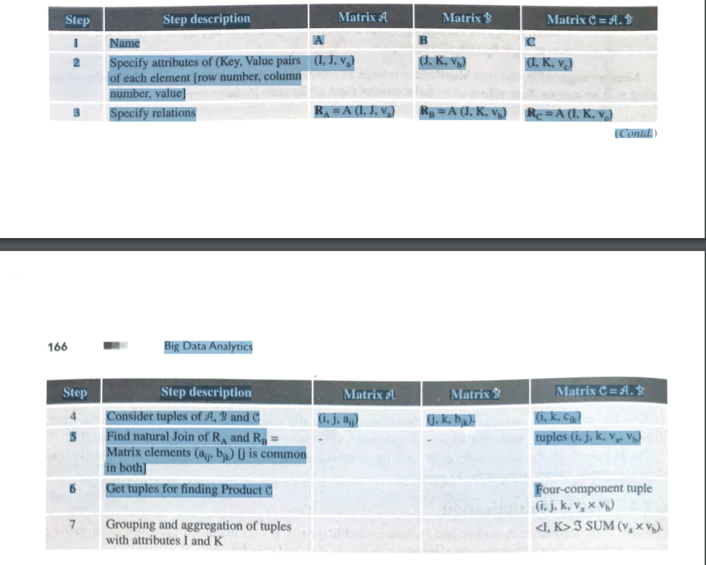

The product AB = Natural join of tuples in the relations RA and Rg followed by grouping and aggregation. Natural Join of A (I, J, va) and B (J, K, Vb), having only attribute J in common = Tuples (i, j, k, Va, Vb) from each tuple (i, j, va) in A and tuples (j, k, vb) in B. 1. MapReduce tasks for Steps 5 and 6: Five-component tuple represents the pair of matrix elements (27j, b;x). Requirement is product of these elements. That means four-component tuple (i, j, k, Va Vp), from equation (4.4) for elements Cik = Sum (47; bjk) j= 1 to je = х (a) Mapper Function: (i) Mapper emits the key-value pairs (j, (A, i, 2;;)) for each matrix element dj, and (ii) Mapper emits the key-value pair (j, (B, k, bik)) for each matrix element ai; (b) Reduce Function: Consider the tuples of A (A, ii,, aij) for each key j, consider tuples of B = (B, k, bik) for each key j. Produce a key-value pair with key equal to (i, k) and value = 2;; * bjk A and B are just the names, may be represented by 0101 and 1010. 2. Next MapReduce Steps 7: Perform I SUM (VAXa Vb). That means do grouping and aggregation, with I and K as the grouping attributes and the sum of va x V) as the aggregation. (c) The Mapper emits the key-value pairs (i, k, .) for each matrix element of C inputs with key i and k, andvc from task earlier of the reducer va X Vb. (d) Reducer groups (i, k, v.) in C using [C, i, k, sum (v.)] from aggregated values of v. from sum (v.). Aggregation uses the same memory locations as used by elements ve C is just the name, may be represented by 1111

**HIVE**

Hive was created by Facebook. Hive is a data warehousing tool and is also a data store on the top of Hadoop. An enterprise uses a data warehouse as large data repositories that are designed to enable the tracking, managing, and analyzing the data. Hive processes structured data and integrates data from multiple heterogeneous sources. Additionally, also manages the constantly growing volumes of data. Fig shows the main features of Hive.

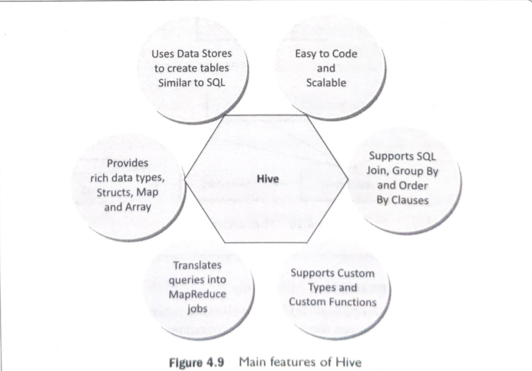

**Hive Characteristics**

1. Has the capability to translate queries into MapReduce jobs. This makes Hive scalable, able to handle data warehouse applications, and therefore, suitable for the analysis of static data of an extremely large size, where the fast response-time is not a criterion.

2. Supports web interfaces as well. Application APIs as well as web-browser clients, can access the Hive DB server.

3. Provides an SQL dialect (Hive Query Language, abbreviated HiveQL or HQL). Results of HiveQL Query and the data load in the tables which store at the Hadoop cluster at HDFS.

**Limitations Hive is:**

1. Not a full database. Main disadvantage is that Hive does not provide update, alter and deletion of records in the database. Not developed for unstructured data.

2. Not designed for real-time queries.

3. Performs the partition always from the last column.

**Hive Architecture**

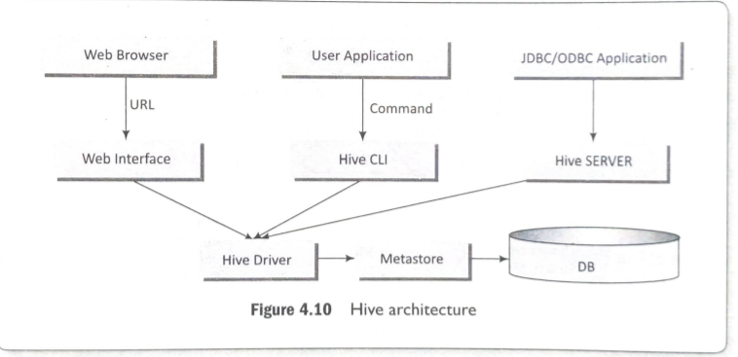

**Components of Hive architecture are:**

**Hive Server (Thrift)** – An optional service that allows a remote client to submit requests to Hive and retrieve results. Requests can use a variety of programming languages. Thrift Server exposes a very simple client API to execute HiveQL statements.

**Hive CLI (Command Line Interface)** - Popular interface to interact with Hive. Hive runs in local mode that uses local storage when running the CLI on a Hadoop cluster instead of HDFS.

**Web Interface** – Hive can be accessed using a web browser as well. This requires a HWI Server running on some designated code. The URL http://hadoop: / hwicommand can be used to access Hive through the web.

**Metastore** – It is the system catalog. All other components of Hive interact with the Metastore. It stores the schema or metadata of tables, databases, columns in a table, their data types and HDFS mapping

**Hive Driver** – It manages the life cycle of a HiveQL statement during compilation, optimization and execution.

**Hive Installation**

Hive can be installed on Windows 10, Ubuntu 16.04 and MySQL. It requires three software packages: Java Development kit for Java compiler (Javac) and interpreter • Hadoop Compatible version of Hive with Java- Hive 1.2 onward supports Java 1.7 or newer. Steps for installation of Hive in Linux based OS are as follows:

1. Install Javac and Java from Oracle Java download site. Download jdk 7 or a later version from http://www.oracle.com/technetwork/java/javase/downloads/jdk7-downloads-1880260.html, and extract the compressed file. All users can access Java by Make java available to all users. The user has to move it to the location "/usr/local/ using the required commands

2. Set the path by the commands for jdk1.7.0_71, export JAVA_HOME=/usr/local/jdk1.7.0_71, export PATH=$PATH: $JAVA_HOME/bin (Can use alternative install /usr/bin/java usr/local/java/bin/java

3. Install Hadoop <http://apache.claz.org/hadoop/common/hadoop-2.4.1/>

4. Make shared HADOOP, MAPRED, COMMON, HDFS and all related files, configure HADOOP and set property such as replication parameter.

5. Name the yarn.nodemanager.aux-services. Assign value to mapreduce_shuffle. Set namenode and datanode paths.

6. Download http://apache.petsads.us/hive/hive-0.14.07. Use ls command to verify the files $ tar zxvf apache-hive-0.14.0-bin.tar.gz, $ ls OR Hive archive also extracts by the command apache-hive-0.14.0-bin apache-hive-0.14.0-bin.tar.gz., $ cd $HIVE_HOME/conf, $ cp hive-env.sh.template hive-env.sh, export HADOOP_HOME=/usr/ local/hadoop

7. Use an external database server. Configure metastore for the server.

**Comparison with RDBMS (Traditional Database)**

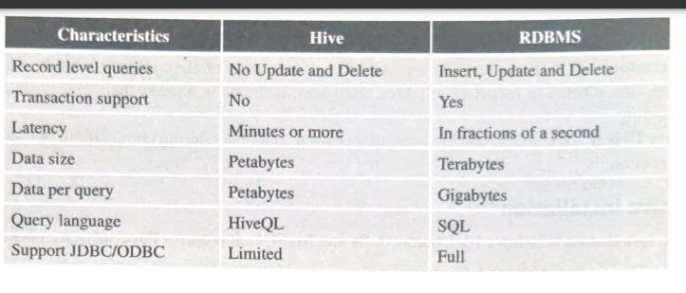

**Hive Data Types and File Formats**

Hive defines various primitive, complex, string, date/time, collection data types and file formats for handling and storing different data formats. Table gives primitive, string, date/time and complex Hive data types and their descriptions.

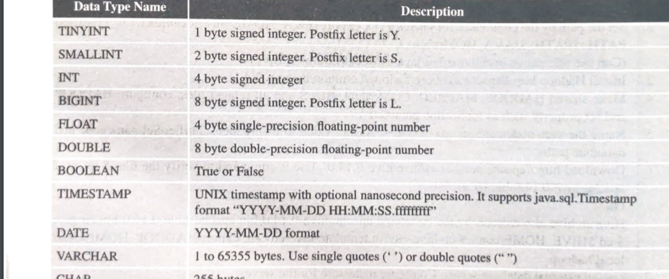

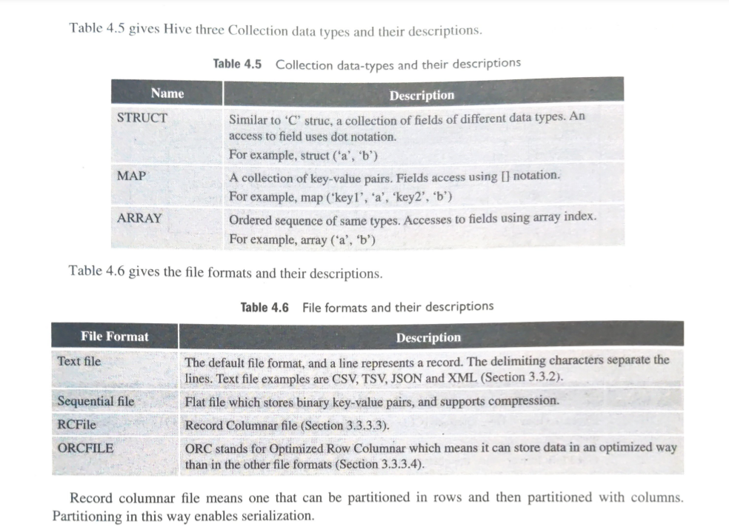

Record columnar file means one that can be partitioned in rows and then partitioned with columns. Partitioning in this way enables serialization.

**Hive Data Model**

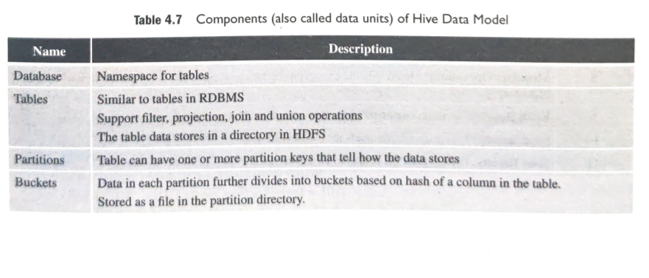

**Hive Integration and Workflow Steps**

Hive integrates with the MapReduce and HDFS. Fig shows the dataflow sequences and workflow steps between Hive and Hadoop.

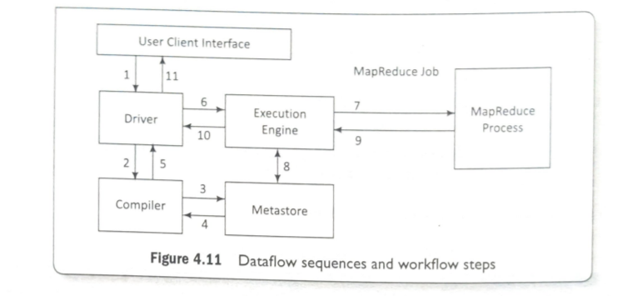

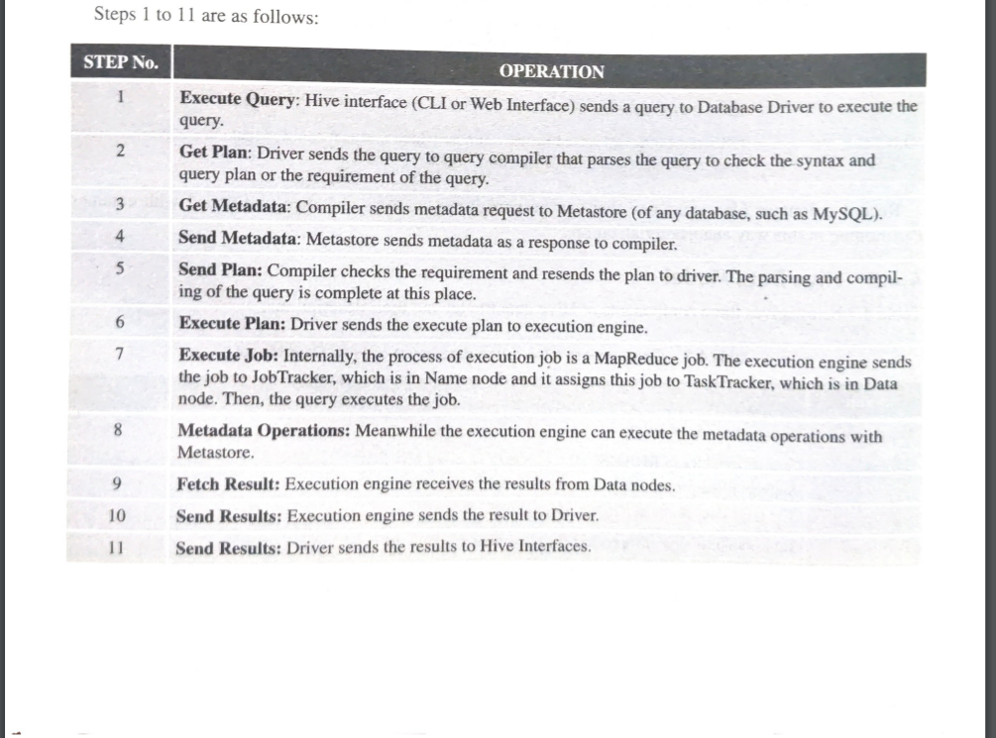

**Hive Built-in Functions**

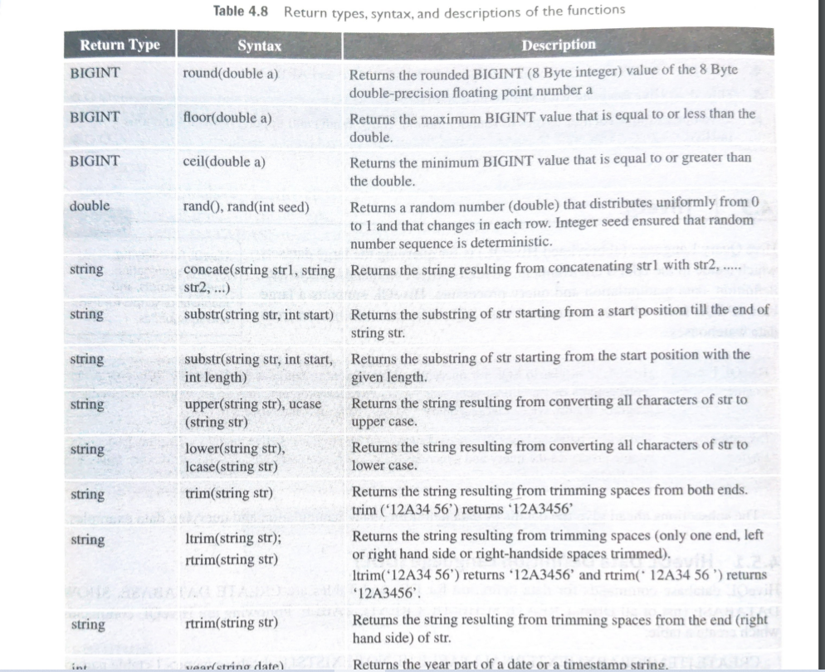

**HiveQL**

Hive Query Language (abbreviated HiveQL) is for querying the large datasets which reside in the HDFS environment. HiveQL script commands enable data definition, data manipulation and query processing. HiveQL supports a large base of SQL users who are acquainted with SQL to extract information from data warehouses.

**HiveQL Data Definition Language (DDL)**

HiveQL database commands for data definition for DBs and Tables are CREATE DATABASE, SHOW DATABASE (list of all DBs), CREATE SCHEMA, CREATE TABLE. Following are HiveQL commands which create a table: CREATE [TEMPORARY] [EXTERNAL] TABLE [IF NOT EXISTS] [.]

|  |  |
| --- | --- |
| [( [COMMENT ], ...)] [COMMENT   |  | | --- | | ] [ROW FORMAT ] [STORED AS ] Table 4.9 gives the row formats in a Hive table. | |

HiveQL database commands for data definition for the DBs and Tables are CREATE DATABASE, SHOW DATABASE (list of all DBs), CREATE SCHEMA, CREATE TABLE. The following example uses HiveQL commands to create a database toys_companyDB.

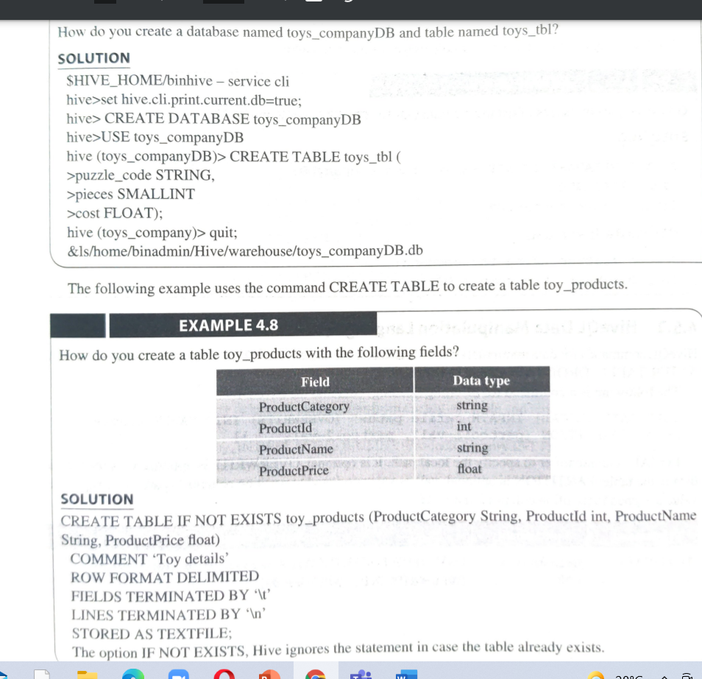

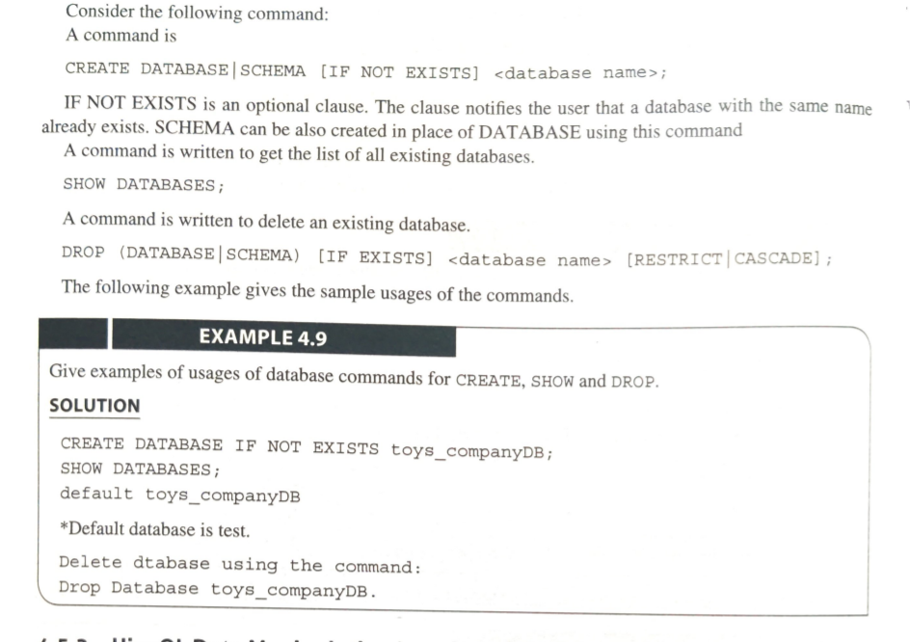

**HiveQL Data Manipulation Language (DML)**

HiveQL commands for data manipulation are USE, DROP DATABASE, DROP SCHEMA, ALTER TABLE, DROP TABLE, and LOAD DATA. The following is a command for inserting (loading) data into the Hive DBs. LOAD DATA (LOCAL] INPATH '' [OVERWRITE] INTO TABLE

|  |
| --- |
| [PARTITION (partcoll=vali, partcol2=val2 ..)] LOCAL is an identifier to specify the local path. It is optional. OVERWRITE is optional to overwrite the data in the table. PARTITION is optional. vall is value assigned to partition column 1 (partcoll) and val2 is value assigned to partition column 2 (partcol2) |

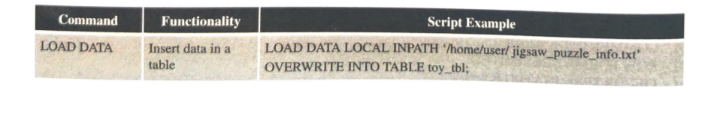

**HiveQL For Querying the Data**

Partitioning and storing are the requirements. A data warehouse should have a large number of partitions where the tables, files and databases store. Querying then requires sorting, aggregating and joining functions.

Querying the data is to SELECT a specific entity satisfying a condition, having presence of an entity or selecting specific entity using GroupBy.

SELECT (ALL | DISTINCT]

|  |
| --- |
| ] [GROUP BY ] [HAVING ] [CLUSTER BY [DISTRIBUTE BY ] [SORT BY ]] [LIMIT number]; |

**Partitioning**

Hive organizes tables into partitions. Table partitioning refers to dividing the table data into some parts based on the values of particular set of columns. Partition makes querying easy and fast.This is because SELECT is then from the smaller number of column fields. Section 3.3.3.3 described RC columnar format and serialized records. The following example explains the concept of partitioning, columnar and file records formats.

Table Partitioning Create a table with Partition using command: CREATE [EXTERNAL] TABLE

|  |  |  |
| --- | --- | --- |
| ( , ..) PARTITIONED BY ( [COMMENT ] , .); Rename a Partition in the existing Table using the following command: ALTER TABLE   |  |  | | --- | --- | | PARTITION partition_spec RENAME TO PARTITION partition_spec; Add a Partition in the existing Table using the following command: ALTER TABLE   |  | | --- | | ADD [IF NOT EXISTS] PARTITION partition_spec [LOCATION 'locationl'] partition_spec (LOCATION 'location2'] | | |

partition_spec: (p_column p_col_value, p_column Drop a Partition in the existing Table using the following command: ALTER TABLE

|  |
| --- |
| DROP (IF EXISTS] PARTITION partition_spec, PARTITION partition_spec; The following example explains concept of add, rename and drop a partition. |

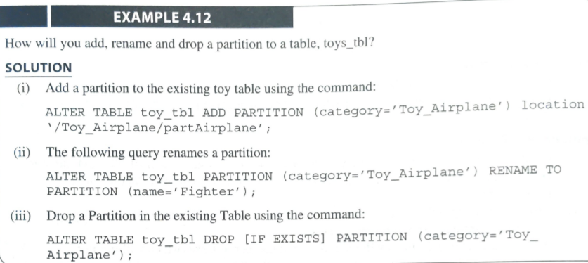

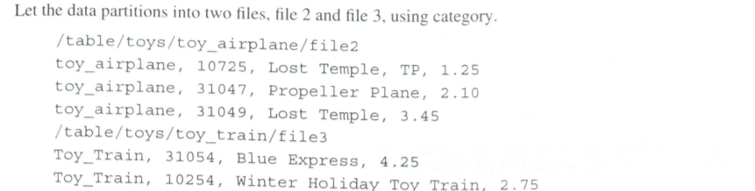

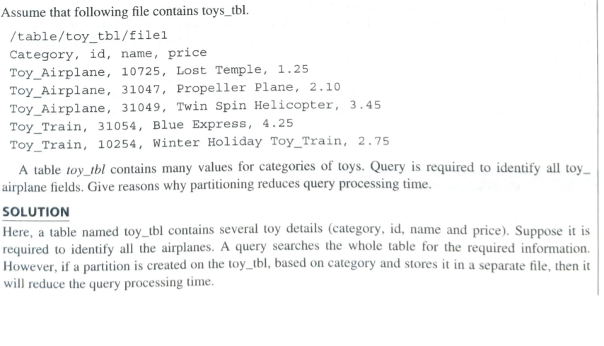

**Advantages of Partition**

1. Distributes execution load horizontally.

2. Query response time becomes faster when processing a small part of the data instead of searching the entire dataset.

**Limitations of Partition**

1.Creating a large number of partitions in a table leads to a large number of files and directories in HDFS, which is an overhead to NameNode, since it must keep all metadata for the file system in memory only.

2. Partitions may optimize some queries based on Where clauses, but they may be less responsive for other important queries on grouping clauses.

3. A large number of partitions will lead to a large number of tasks (which will run in separate JVM) in each MapReduce job, thus creating a lot of overhead in maintaining JVM start up and tear down (A separate task will be used for each file). The overhead of JVM start up and tear down can exceed the actual processing time in the worst case.

**Bucketing**

A partition itself may have a large number of columns when tables are very large. Tables or partitions can be sub-divided into buckets. Division is based on the hash of a column in the table. Consider bucketed column Cbucket_i.. First, define a hash_function H() according to type of the bucketed column. Let the total number of buckets = Nbuckets. Let Cbucketi denote ith bucketed column.

The hash value h; = hashing function H(Cbucket_j) mod (Nbuckets). = Buckets provide an extra structure to the data that can lead to more efficient query processing when compared to undivided tables or partition. Buckets store as a file in the partition directory. Records with the same bucketed column will always be stored in the same bucket. Records kept in each bucket provide sorting ease and enable Map task Joins. A Bucket can also be used as a sample dataset. CLUSTERED BY clause divides a table into buckets. A coding example on Buckets is given below: